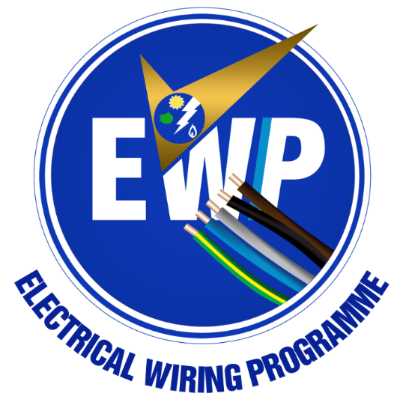

APPLICATION FORM FOR FULL IMPLEMENTATION INSPECTORS

CERTIFIED ELECTRICAL WIRING PROFESSIONAL –INSPECTOR (CEWP-I)

Please attach 1 passport picture

APPLICATION FORM

The Certified Electrical Wiring Professional-Inspector Certificate is issued to qualified personnel certified to undertake Inspection and Testing in accordance with the full implementation of the Electrical Wiring Regulation, 2011, L.I.2008.

FALSIFICATION IN FILLING OUT THIS APPLICATION IS SUFFICIENT CAUSE FOR REFUSAL TO ISSUE A REGISTRATION.

A-1 Applicants personal data (use block letters)
SURNAME: __________________________________FIRST NAME: _____________________________
OTHER NAME (S): ___________________________TELEPHONE NUMBER: _________________________
CEWP License PIN No: _____________________________ (original copy of License to be submitted)
A-2 Applicants to be licensed for Inspection and testing of: (check all that apply)

Domestic elect installation Commercial elect installation Industrial elect installation

A-3 Association/Professional Body
Association/ Professional Body Name:_____________________________________________________
Chapter: ___________________________ECG/NEDCo District/Area: ____________________________
Region: _____________________

Association Stamp & Signature: _______________________________
A-4 Applicants Level of Education
NAME OF INSTITUTION | FROM | TO | CERTIFICATE

A-5 Applicants Work Experience (Installation Completion Certificates)
Applicants will be required to produce the following as evidence of electrical wiring works carried out:
- Form A, B, & Minor Works Form (Used & Unused)
- Copies of Basic Test Sheets (If available)

A-6 Processing Fee
Payment of Processing Fees must be made to Ghana Commercial Bank

Account Name: Energy Commission – Electrical Wiring Regulation

Account no.: 1011130039212 Branch: High Street Branch

Fee: GHC250.00

NB: PLEASE ATTACH ORIGINAL COPY OF PAY-IN SLIP TO THE FORM

A-7 I CERTIFY THE INFORMATION PROVIDED IS COMPLETE AND ACCURATE. I HAVE ALSO ENCLOSED THIS FORM WITH RECEIPT OF PAYMENT

________________________________ __________________________
Applicant’s Signature Date

Please complete and return to:
Office of the Energy Commission, District CEWP Association or Local GECA Office as well as any other center that will be communicated to you by the Energy Commission.

Locate our office at the Ghana Airways Avenue in the Airport Residential Area behind Alliance Française
Contact us on: 0506344713, 0249229306, 0302 813756-9 Email: electricalghana@yahoo.com

A-8 Applicants Access to Electrical Tools/ Instruments

NAME OF TOOL/ INSTRUMENT  (eg. Insulation Resistance Tester) | BRAND  (eg. Megger) | SERIAL NO.  (eg. 100187) | LAST DATE OF CALIBRATION  (eg. 10th Sept, 2016) | TOOL OWNERS NAME & CONTACT  (Yeboah Atinga & 029xxxxxx)

